|  | 1. To study AWK programming |
| --- | --- |

| **Name of Student** | **Hardik Prajapati** | **Roll No.** | **9152** |
| --- | --- | --- | --- |
| **Sign here to indicate that you have read all relevant material provided /available on Moodle while performing and writing this experiment** | | **Sign:** | |

**Late Submission Details (if any)**

| **Reason(s) of late submission** | **Date of practical performance** | **Date of practical submission** |
| --- | --- | --- |
|  |  |  |

**References used**

| 1 | Name and author of reference book(s) with page nos. |  |
| --- | --- | --- |
| 2 | Name and roll nos. of the peers whose help you have taken (if any) |  |

| Rubrics for assessment of Experiment:   | Indicator | Poor | Average | Good | | --- | --- | --- | --- | | Timeliness  Maintains Experiment deadline (3) | Experiment not done (0) | One or More than One week late (1-2) | Maintains deadline (3) | | Completeness and neatness  Complete all parts of Experiment (3) | N/A | < 80% complete (1-2) | 100% complete (3) | | Originality  Extent of plagiarism (2) | Copied it from someone else (0) | At least try to implement but could not succeed (1) | Implemented (2) | | Knowledge  In depth knowledge of the Experiment (2) | Unable to answer any questions (0) | Unable to answer few questions (1) | Able to answer all questions (2) | |
| --- | --- | --- | --- | --- | --- | --- | --- | --- | --- | --- | --- | --- | --- | --- | --- | --- | --- | --- | --- | --- |
| Assessment Marks:   | Timeliness |  | | --- | --- | | Completeness and neatness |  | | Originality |  | | Knowledge |  | | Total |  | |

**Signature of Teacher with date**

| **1.** | **Course, Subject & Experiment Details** |
| --- | --- |

| **Course & Branch** | **T.E. (ECS)** | **Estimated Time** | **02 Hours Per Week** |
| --- | --- | --- | --- |
| **Current Semester** | **Semester VI** | **Subject Name** | **Linux Server Administration** |
| **Chapter No. & Unit** | **5.1** | **Chapter Title** | **Bash Shell Scripting** |
| **Experiment Type** | **Software Performance** | **Subject Code** | **ECL 604** |

| **2.** | **Aim & Objective of Experiment** |
| --- | --- |

1. **To write programs using awk programming**

| **3.** | **Expected Outcome of Experiment** |
| --- | --- |

1. **To understand awk programming**

| **4.** | **Brief Description of the experiment** |
| --- | --- |

Refer the website: <https://zetcode.com/lang/awk/>

1. Print all words included in the **words.txt** file that are longer than eight characters.

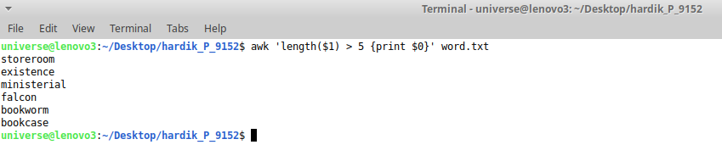

1. Print all words that have three characters from **words.txt**

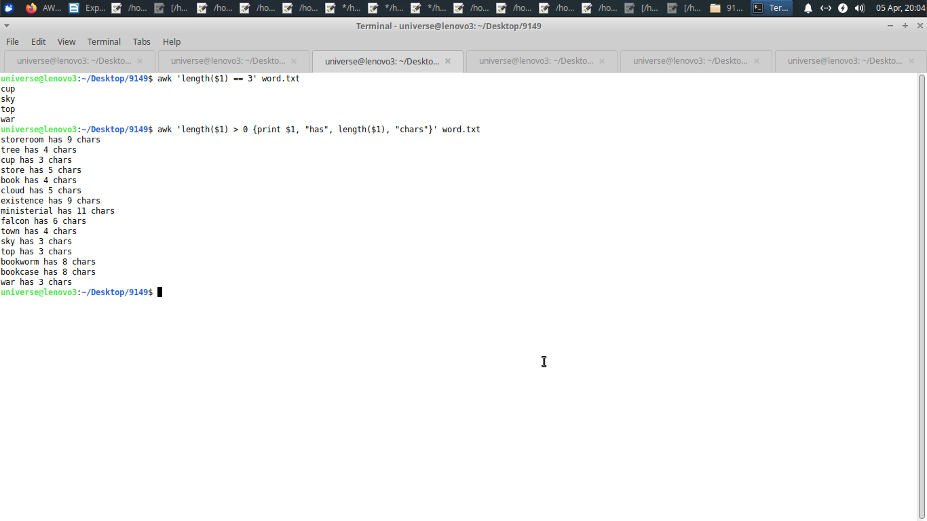

1. Print all words in the file **words.txt** along-with the length of each.

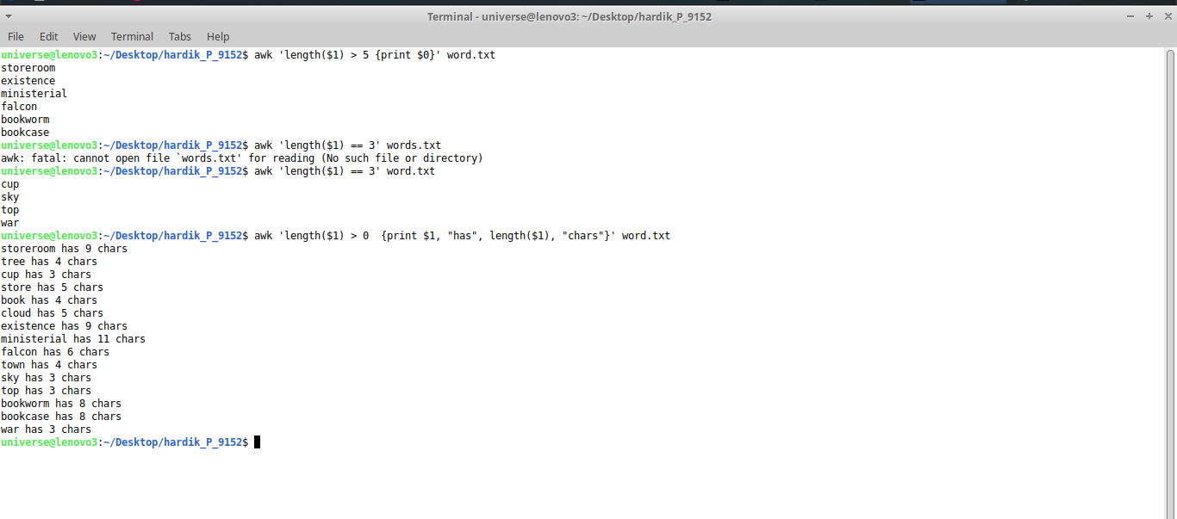

1. Print all students with scores 90+ from **scores.txt**

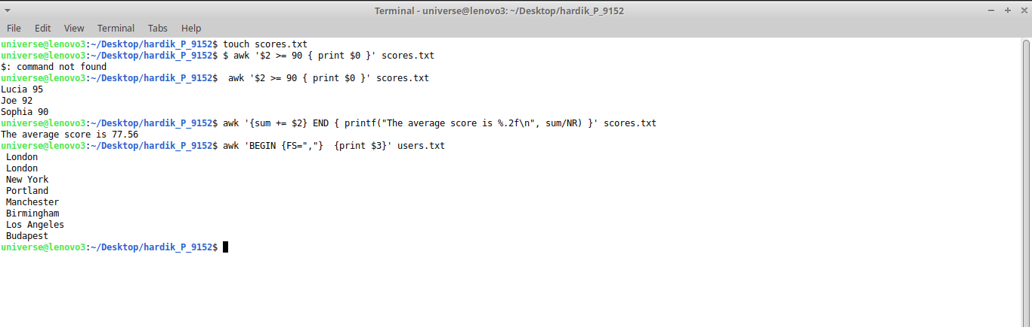

1. Print average of all scores from **scores.txt**



1. Print unique names of cities from **users.txt**



1. Print names of all females with the number of characters in the name from **users.txt**

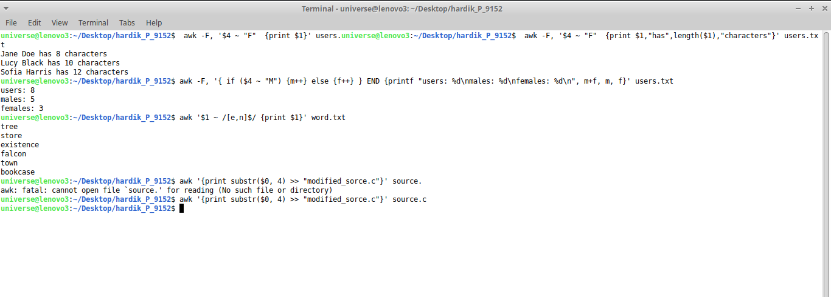

1. Print total no. of users, total no. of males and females from **users.txt**



1. Prints all words that end with e or n from **words.txt**

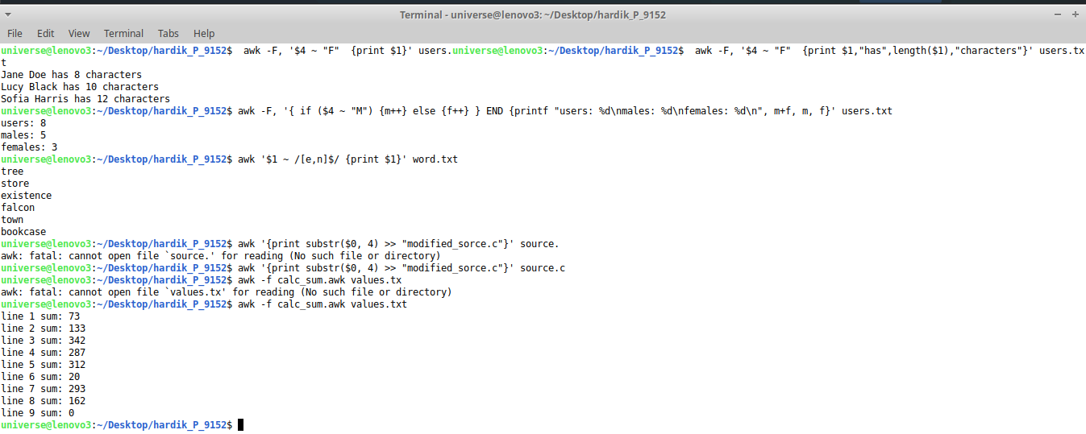

1. Remove line numbers from source.c file and save the extracted program (without line numbers) in another file **modified_source.c**



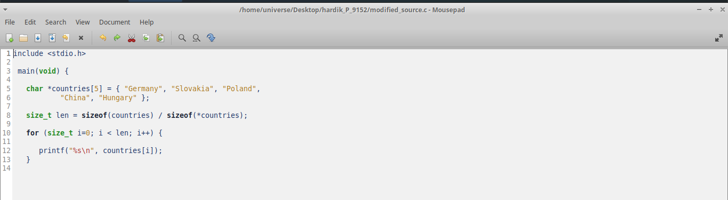

1. Print sum of all numbers (line wise) from **values.txt**



1. **Do this for extra credits: Make any one game using awk**

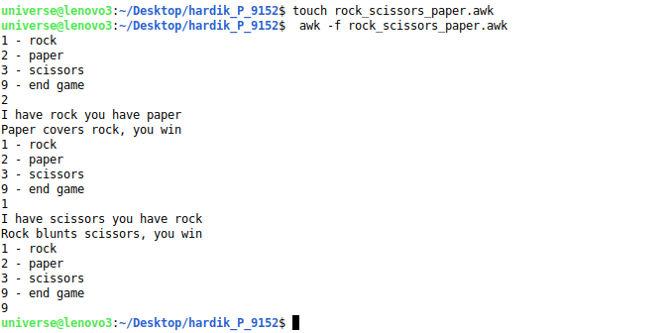

| **5.** | **Conclusions & Inferences** |
| --- | --- |

| **6.** | **Post Lab exercise** |
| --- | --- |

1. Write a note on “sed programming” with the help of an example code